**Lab 2**

1. **Theory : Write about the Constraints in SQL**

Constraints are the rules that we can apply on the type of data in a table. That is, we can specify the limit on the type of data that can be stored in a particular column in a table using constraints.

The available constraints in SQL are: 

* **NOT NULL**: This constraint tells that we cannot store a null value in a column. That is, if a column is specified as NOT NULL then we will not be able to store null in this particular column any more.
* **UNIQUE**: This constraint when specified with a column, tells that all the values in the column must be unique. That is, the values in any row of a column must not be repeated.
* **PRIMARY KEY**: A primary key is a field which can uniquely identify each row in a table. And this constraint is used to specify a field in a table as primary key.
* **FOREIGN KEY**: A Foreign key is a field which can uniquely identify each row in a another table. And this constraint is used to specify a field as Foreign key.
* **CHECK**: This constraint helps to validate the values of a column to meet a particular condition. That is, it helps to ensure that the value stored in a column meets a specific condition.
* **DEFAULT**: This constraint specifies a default value for the column when no value is specified by the user.

1.Create a database **<yourname>dbms2**

**Output:**



2.Create tables

**a.student** (id(int), name, gender, program, contact\_number, address)

**Query:**

create table student (

id int,

name varchar(100),

gender varchar(10),

program varchar(100),

contact\_number varchar(15),

address varchar(150)

);

**Output:**

IMG_256

**b.teacher** (id(int), name, subject, contact\_number, address)

**Query:**

create table teacher (

id int,

name varchar(255),

subject varchar(255),

contact\_number varchar(15),

address varchar(255)

);

**Output:**



c.Set NOT NULL constraint on the "id" column for both tables

**Query:**

alter table student modify id int not null;

alter table teacher modify id int not null;

**Output:**

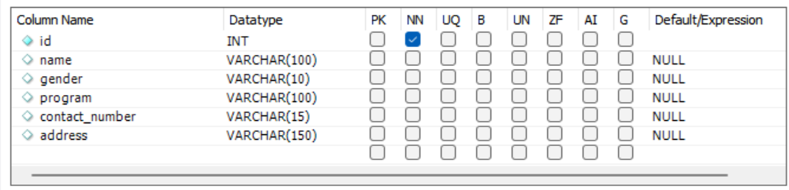

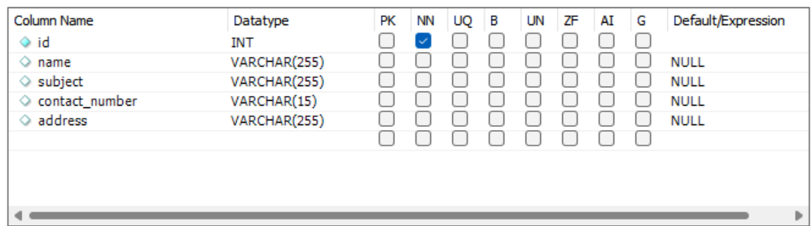

d. Set UNIQUE constraints on the “id: column

**Query:**

alter table student modify id int unique;

alter table teacher modify id int unique;

**Output:**





1. Set NOT NULL constraint on the **contactno** column in the existing **teacher** table.

**Query:** alter table teacher modify contact\_number varchar(15) not null;

**Output:**

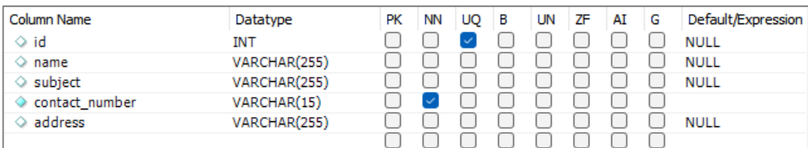

1. Set NOT NULL constraint on the **address** column in the existing **student** table.

**Query:** alter table student modify address varchar(150) not null;

**Output:**

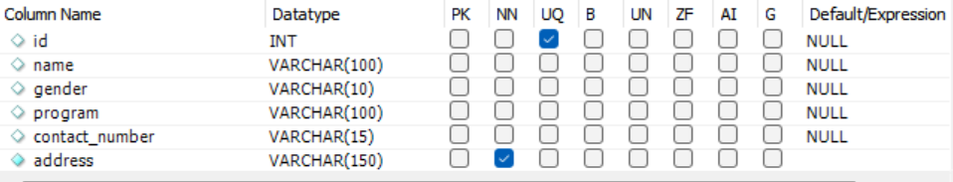

1. Set PRIMARY KEY on the **id** column on the **teacher** table

**Query:** alter table teacher add primary key (id);

**Output:**

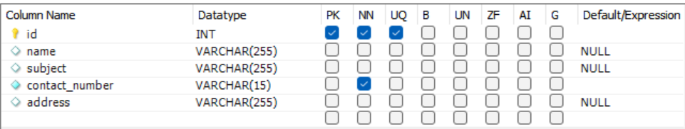

6.Set PRIMARY KEY on the **id** column on the **student** table.

**Query:** alter table student add primary key (id);

**Output:**

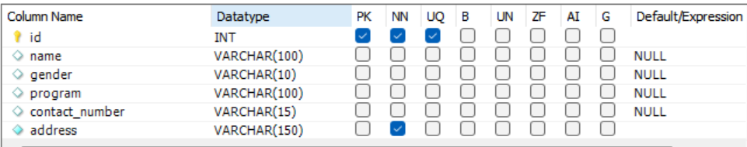

7.Set DEFAULT VALUE of **program** as “**CSIT”** in **student** table.

**Query:**alter table student alter column program set default 'CSIT';

**Output:**

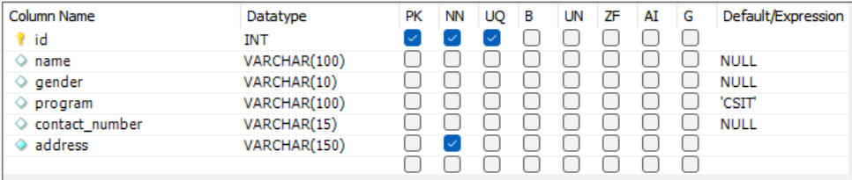

1. Set DEFAULT VALUE of address as “Ekantakuna” in student table

**Query:**alter table student alter column address set default 'Ekantakuna';

**Output:**

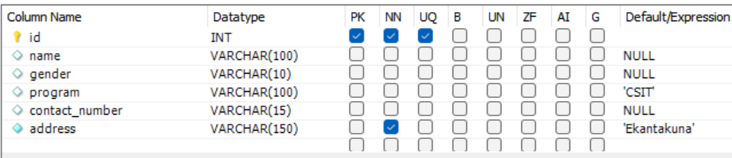

1. Delete the constraint PRIMARY KEY on the **id** column on  **teacher** table.

**Query:** alter table teacher drop primary key;

**Output:**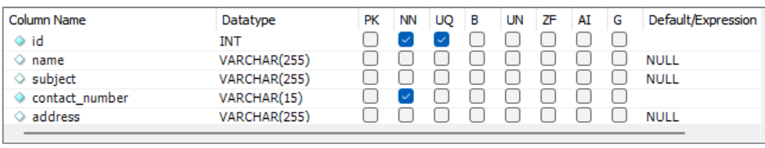

1. Delete NOT NULL constraint on the **id** column for **teacher** table.

**Query:** alter table teacher modify id int NULL;

Output:

